C.A.R.E. LEARNING CENTRE

Community Education Programmes

Development
TERM 2018

C.A.R.E. Learning Centre
38 Mount Hill
Pembroke HM 09
Tel: 292-0915 Fax: 295-8481
E-mail: admin@care.bm

“Educating the Community”
C.A.R.E Learning Centre

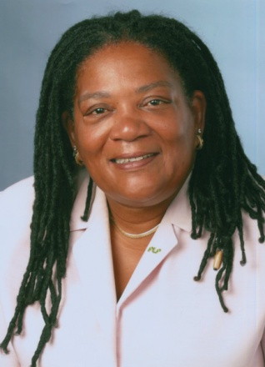
DIRECTOR’S FORWARD

C.A.R.E. stands for Children and Adults Reaching for Education. C.A.R.E. is an academic learning centre with a computerized educational lab where students learn with the aid of computers, smart boards and iPads. The learning centre provides a high quality, values-based education where students learn to respect themselves and others. Morning, afternoon and evening courses are now available to young adults such as Employability Skills, Computer Skills, Writing Skills, Math Skills and G.E.D. Preparation. New this term is Computer Essentials and Workplace Essentials. Our classes are conveniently located with ample parking facilities. You progress at your own speed, and have access to web-based software 24/7 such as the G.E.D. Academy. Classes are taught by instructors who specialize in working with adult learners. We are especially thankful to our partners, the Ministry of Public Works, the Department of Workforce Development and private organizations and businesses.

PURPOSE
To provide programmes that address learning difficulties, social skills, training and employability skills. Address the needs of young adults and adults particularly those who are suffering from drug abuse, alcohol abuse, low self-esteem, violence, numeracy and literacy skills and other educational requirements for employment goals and careers.
MISSION STATEMENT
The mission of C.A.R.E. Learning Centre is to provide a positive and supportive learning environment that values and respects the self-worth and uniqueness of each individual. Provide students with the necessary academic, social and technological skills to allow them to develop to their maximum potential.

COURSE SCHEDULE 2017/18
REGISTRATION INFORMATION
REGISTRATION DATES:
September
PAYMENT METHODS:
On-line, Cash or Cheques
On-line Registration: www.care.bm
or fax 295-8481
CLASSES BEGIN: Open Entry
CLASSES END: 3rd week in June
C.A.R.E. Learning Centre
38 Mount Hill
Pembroke HM 09
Tel: (441) 292-0915 Fax: (441) 295-8481
Email: admin@care.bm
REGISTRATION REQUIREMENTS
Students must have identification for registration
(i.e. Driver’s License, passport or voters card)
S ee your goal
U nderstand obstacles
C reate a positive mental picture
C lear your mind of self-doubt
E mbrace the challenge
S tay on track
S how the world you can do it

GENERAL INFORMATION
PAYMENT OF FEES
All cheques are to be made payable to C.A.R.E. Learning Centre.
- Fees are payable on Mondays for weekly students in the afternoon programme only.
- Fees are payable per session for single session students.
- Special arrangements for monthly payments must be made with the DIRECTOR.
All G.E.D. students’ fees and assessments payable in advance.
- NO REFUNDS are made for missed sessions. You are entitled to “make-up” sessions within a limited period
- Students not attending for a period of one week will still be charged for their regular session.
This applies only to the afterschool programme students.
REFUND POLICY
Fees are refundable for Cancelled Courses ONLY. The back of the original receipt should be signed and submitted to the office. Please note, the cheque requires at least two (2) weeks for processing.
BOOKS, MATERIALS AND SUPPLIES
Textbooks and calculators are available from C.A.R.E. Learning Centre.
“Education is more than a luxury; it is a responsibility that society owes to itself.”
– Robin Cook

C.A.R.E. SCHOOL RULES
C.A.R.E. LEARNING CENTRE
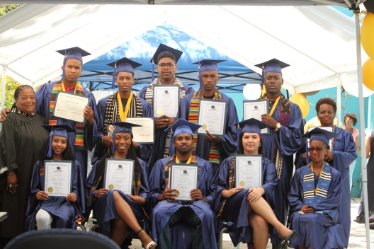
In order to ensure the successful operation of our programme, let me share some things that are required of our students.
  - NO chewing gum
  - NO rocking of chairs
  - NO running up/down the stairs
  - NO music/headphones, cell phones or hats on during class
  - NO hanging outside the building
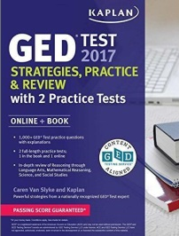

  - NO eating or drinking in classroom
C.A.R.E. stands for
Children and Adults Reaching for Education
C.A.R.E. is an academic learning centre with a computerized educational lab where students learn with the aid of computers.
  - NO LOUD talking in classroom
  - When leaving building please move QUIETLY
  - NO cut-off jeans
Students must wait until assigned to computers. They can entertain themselves by QUIETLY reading books or doing homework.
ALTERNATIVE EDUCATION
SPECIAL PROGRAMME FOR SCHOOL LEAVERS
Upgrading their skills to obtain their high school diploma through our new computerized G.E.D. programme
Course contains four subjects:
Reasoning through Language Arts, Science, Social Studies and Mathematical Reasoning

G.E.D. students can work in their G.E.D. textbooks.
Students should pay attention to their own computer.
If students have any questions while working on the computers, they must call for assistance.

PRODUCTIVE COURSES
- Computer Skills
- Microsoft Word
- Microsoft Office
- Internet Skills
- Keyboard Skills
- Smartboard Skills
SUCCESS IN THE WORKPLACE

BASIC SKILLS UPGRADE
- Math Skills
- Problem Solving
- Language Arts
- Reading Skills
- Spelling Skills
- Writing Skills
GED ASSESSMENT

PLEASE NO EATING OR CHEWING GUM AT THE LEARNING CENTRE

CERTIFICATES
A Certification of Completion will be processed for further education, professional development and employability courses ONLY.
READING/LANGUAGE ARTS
- Initial Reading
- Reader’s Workshop
- Critical Reading Skills
- Practical Reading Skills
- The Reading Network
- Fundamental of English

“Teachers touch the minds
and hearts of their students”

AFFILATIONS
- G.E.D. Academy
- Pearson Vue Testing Centre
- G.E.D. Testing Service

G.E.D. PREPARATION COURSES
The GED Preparation Course comes with four independent sub-tests. The four tests are on the academic subject fields of: Science, Social Studies, Literacy and Mathematics. Science (90 minutes) includes content areas such as life science, physical science (physics and chemistry) and earth and space science. The Social Studies test (90 minutes) includes questions on these areas: U.S. History, World History, Economics, Geography, Civics and Government. Literacy (Reasoning through Language Arts, 150 minutes) contains questions on topics such as punctuation, sentence structure, grammar, spelling, poetry and drama, prose fiction and nonfiction. Math (Mathematical Reasoning, 115 minutes) addresses subject fields like algebra, probability, functions, data analysis, statistics and number operations to mention a few.
Testing needs to be done at an official approved GED testing centre (Bermuda College). Online testing is NOT possible.
Morning Classes: Monday, Tuesday and Thursday
Time: 9:00 a.m. – 11:30 a.m.
Fees: $1,400.00
Afternoon Classes: Monday and Thursday
Time: 1:00 p.m. – 3:00 p.m.
Fees: $1,300.00
Evening Classes: Monday and Thursday
Time: 4:30 p.m. – 6:30 p.m.
Fees: $1,300.00
Course length per term is 10 weeks, classroom instruction is included in this computerized course.
MYGED READINESS ASSESSMENT
The only practice test designed to assess how students will do on the GED® test.

BENEFITS
- Tells students if they are likely to pass
The GED Ready® practice test has the same look and feel as the real GED® test, and gives students firsthand experience answering computer-based test questions written and developed by the test’s creators. The score report tells students if they are likely to pass or if it’s too close to call and they should keep studying.
- Same-day scores
Evaluate your test-takers’ same-day GED Ready® practice test scores and decide if they’re prepared to test. You’ll be able to identify areas of strength and weakness and immediately work on improvements.
- Focused study plans
The GED Ready® practice test is synced to publisher books and courses and gives every student their own targeted study plan based on the skills he or she needs to work on, including specific guidance on what to study in publishers’ test prep materials.
*This assessment is mandatory for enrollment in the G.E.D. Preparation Course
Time: Available on request by appointment
Cost: $250.00
“The MyGED Ready assessment was such a significant help to my success. The assessment helped me to see what areas I needed to improve on before I took the test.” Tyler, GED Graduate 2016.
GED ACADEMY

Our self-directed, cloud-based software application prepares adult students for the GED test, college and career readiness. Adaptive learning technology combines GED lessons across four subject areas into a personalized lesson plan that challenges students and keeps them engaged and motivated. Interactive instruction in core subject content areas of math, science, social studies, language arts, writing and computer skills are presented in engaging, revelant and motivating experiences. Students draw faster connections to the information and retain more of what they learn. As students work through the recommended lessons, the GED Academy advances the student through content designed for progressively higher functional levels through grade 12.
Diagnostic Assessment accelerates students learning with a personalized student’s knowledge level. Students become familiar with how to answer interactive questions which are randomized so students can retake the test. Practice is timed just like the real GED test and using the same weighing to score results.


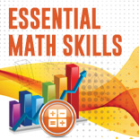
For each missed question, the assessment prescribes a mini lesson of combined GED Academy and Essential Skills Practice workbook lessons.
Cost per term
Morning classes: $1,400.00
Afternoon classes: $1,300.00
Evening Classes: $1,300.00
Course length per term is 10 weeks, classroom instruction is included with this computerized course.
EMPLOYABILITY SKILLS

A multimedia course that contains activities and exercises based is all computer-based instruction programmes. In addition to this, emphasis will be on integrating technology in all subject areas utilizing Microsoft Word, Excel, PowerPoint, Internet Skills and Keyboard Skills. The clients who will attend and who are from our community deserve the best that we can give them. Clients will focus on reading comprehension, vocabulary development, critical reading skills, computational skills, word problems, problem-solving skills and development of a positive work ethic through a combination of programmes.
Programme course length – 4 weeks
Certificate of completion provided to present to potential employers.
Afternoon Classes: Tuesday
Time: 1:00 p.m. – 3:00 p.m.
Evening Classes: Thursday
Time: 4:30 p.m. – 6:30 p.m.
Fees: $150.00


WORK ESSENTIALS


Work Essentials gives you everything you need to help students find and keep their dream job, and then impress their employer and coworkers. This six unit online course is positioned for the high school equivalency candidate, as well as adults who have their high school diploma, but have not been successful at getting the job they want. In these units, students will learn how to write a great resume and use networks to land the job of their dreams. Even better, they’ll learn how to think like an employer and say the right things in an interview. This is a computerized course, students must be computer literate. (Certification)
Afternoon Classes: Tuesday and Thursday
Time: 1:00 p.m. – 3:00 p.m.
Fees: $250.00
COMPUTER ESSENTIALS


With our self-paced on-line digital literacy course, students can study at home and in the classroom to learn computer and internet skills required or college and career. Increase learning productivity in the classroom by closing digital skills gap. Promote responsible digital citizenship, practicing legal and ethical online behaviour is a must in the modern internet era.
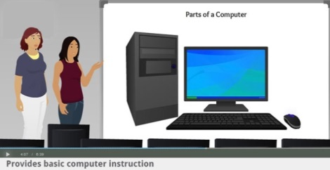
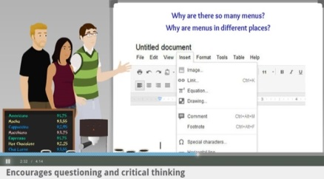

Build students’ technology skills, learn to navigate software applications, operating systems and the internet. Fundamental skills include keyboarding, opening and closing windows, scrolling, navigating menus and using hotspots. These skills are critical to success in online tests and knowledge work. Builds Self-Confidence and Mastery of Computer Skills. (Certification)
Morning Classes: Wednesday
Time: 10:00 a.m. – 12 noon
Afternoon Classes: Wednesday
Time: 1:00 p.m. – 3:00 p.m.
Fees: $250.00

ADDITIONAL COMPUTER CLASSES


INTRODUCTION TO MICROSOFT OFFICE
This course caters to participants who have no experience using the computer. You will be instructed on how to utilize the Windows application, create a document and folders and save a document. Flash drive required for class.
Programme course length – 4 hourly sessions
Evening Classes: Wednesday
Time: 6:00 p.m. – 7:00 p.m.
Fees: $150.00
INTRODUCTION TO MICROSOFT WORD

This is a moderately pace class for beginners and refresher users. Participants will be taught how to type and save documents, create, enter, edit and format text. Users can start with a blank document or work from a customized template for work projects and reports. Participants will be able to create and save a document relevant to their job function. Limited space is available.
Programme course length – 4 hourly sessions

Morning Classes: Friday
Time: 10:00 a.m. – 12 noon
Fees: $150.00
INTRODUCTION TO MICROSOFT EXCEL

Discover and compare different ways to represent your data and your intents visually. When you see the one that shows your data best, apply formatting, charts and tables with a single click. A set of charts and graphs will help you present your data in fresh ways. This course is an introduction to the usage of software application. Basic computer skills required.
Programme course length – 4 hourly sessions

Morning Classes: Friday
Time: 10:00 a.m. – 12 noon
Fees: $100.00

INTERNET USAGE
Whether you call it the Internet, the Net, or the Web and you want to use it for business, homework, research, communicating or shopping, the learning centre is available to you. The computer lab is fully equipped for your needs and privacy.
Time: On request
Cost: $25.00 per hour
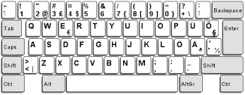
KEYBOARDING FOR SENIORS
Sharpen your keyboard using a programme which offers individualized lessons, effective learning, skill building games, practice sessions and unique tools to advance your knowledge of touch typing.
Programme course length – 4 hourly sessions
Morning Classes: Wednesday
Time: 10:00 a.m. – 12 noon
Fees: $75.00
IPAD TRAINING F0R SENIORS

This course is designed for seniors to learn how to use: Are you thinking about buying an iPad and want to learn more about it? Or do you own an iPad and want to put it to better use? These lessons are designed for beginners and will cover the very basics from what that round button at the bottom of the iPad does to how you can move or delete an app. There is even a lesson with tips that will help you get the most out of the iPad and perhaps even teach your friends a neat trick or two. The first lesson deals with the actual iPad, including what comes in the box and what that circular button at the bottom does and the basics of the iPad's user interface. You will also learn how to find the web browser so you can surf on the Internet, how to play music on the iPad, how to buy music and movies from the iTunes store and how to boot up the app store so you can start downloading apps.
Programme course length – 4 hourly sessions
Morning Classes: Wednesday and Friday
Time: 10:00 a.m. – 12:00 noon
Fees: $150.00
UPGRADE SKILLS PROGRAMMES
MATH SKILLS

This course is designed to enable students to pass the Mathematical Reasoning test of the G.E.D. Preparation Course and to meet the high school diploma requirements. This course is also available to Senior Secondary Students. The course deals with a number of basic mathematical concepts that will be used during your study and/or work life. When you have worked through this unit you will be able to:
- Understand the number system and relationships between sizes of objects
- Appreciate and work with some basic elements in algebra and algebraic manipulation
- Solve simple and simultaneous equations and transpose equations
- Apply rounding rules to the results of calculations
- Calculate binomial coefficients
- Use an extended set of calculator functions
Programme course length – 8 sessions
Afternoon Classes: Tuesday
Time: 1:00 p.m. – 2:00 p.m.
Fees: $300.00

BASIC MATHEMATICS

Basic Mathematics is a course for students whose placement and diagnostic tests indicate a need to review and strengthen basic mathematics skills. The course will consist of a study of whole numbers, fractions, decimals, exponents and order of operations, ratio and proportion, percent, measurement and the metric system, introductory statistics, and graphs. Emphasis will be placed on word problems that involve applications of the above topics. To exit this course you must earn a minimum grade of C. The course includes tutorials and a final test.
Programme course length – 8 hourly sessions
Morning Classes: Wednesday
Time: 9:30 a.m. – 11:30 a.m.
Fees: $350.00

BASIC WRITING SKILLS

This course focuses on the basic elements of traditional English grammar, including parts of speech, parts of the sentence, dependent and independent clauses, mechanics, punctuation and usage needed for clear writing. Students will develop a practical understanding of the fundamentals of grammar through class discussion, the working out of grammatical problems, evaluating various forms of writing and writing sentences and paragraphs.
Programme course length – 8 hourly sessions
Morning Classes: Wednesday
Time: 9:30 a.m. – 11:30 a.m.
Fees: $350.00
RESUME WRITING AND INTERVIEW SKILLS


Putting your best foot forward in a period of transition can be a challenge. How can you construct a resume and cover letter that will get noticed in today’s job market? In this two-session course, we will share best practices in writing resumes and cover letters and discuss ways to improve your interviewing skills, including review what to do before, during and after the interview. We will note different types of interviewing techniques, and provide tips on how to present you in the best light. We will talk about what to wear to an interview, and review questions to ask the prospective employer. You will have the opportunity to have your resume reviewed by the instructor and your peers, and engage in a brief, optional mock interview. This constructive feedback will allow you to make revisions to your resume and enhance your interviewing skills to present you in the best way possible.
Programme course length – 2 sessions
Afternoon Classes: Wednesday
Time: 1:00 p.m. – 2:00 p.m.
Fees: $75.00

AFRICAN CENTRED EDUCATION

African centeredness is the placement of African people and students at the centre of human process. This is based on the belief that all humans have their played physical, social and intellectual origins in Africa. African Centred Education places the student at the centre of the educational experience as a subject rather than an object. The placement of the student at the centre allows for an inclusionary process which gives equal representation of all groups. African Centered Education acknowledges the scientific fact that humanity began in Africa. It is an approach which celebrates the culture, heritage, contributions and traditions. Self-esteem through culture leads to academic excellence. Materials for this class provided by C.A.R.E., Space is limited.
Programme course length – 3 sessions (when applicable)
“Children who fail to know their own history and culture are apt to believe that their history and culture are secondary importance at best. The best way to tap their creativity and intelligence of a child is to centre the child first in his/her own historical and cultural experience” – Kwame Kenyetta
Instructor: Dr. Muriel M. Wade Smith
Evening Classes: Tuesday
Time: 5:30 p.m. – 7:00 p.m.
Fees: $150.00

TUTORIAL SERVICES
C.A.R.E. provides tutorial services for primary, middle, senior secondary students, home schooled and private school students, in the areas of mathematics, problem solving, English, spelling, comprehension, science, social studies, algebra, computer skills and keyboard skills. Parent, these programmes will enhance the learning path of your child, an after-school programme that will meet their needs. Let C.A.R.E. help you to motivate your child to LEARN and secure their future.
Time: Monday and Thursday (additional days on request)



Cost: Per session – Primary School $25.00, Middle School $30.00, Senior School $35.00
HOLIDAY CAMPS (Easter, Summer and Christmas)
These camps are designed to help students strengthen their learning skills and motive students to seek higher levels of achievement in the area of reading, writing and math skills. As well as providing experiences that focus on computer and science technology. “Each one, Reach one, Each one, Teach one”

- Art and Crafts
- Games
- Movies and Field Trips
- Computer Skills
- iPad Skills
- Swimming

Time: 8:30 a.m. – 5:30 p.m.
Fees: $125.00 per week
Camps will be advertised for enrollment. Registration fee $10.00
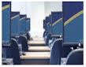
PEARSON VUE AUTHORIZED TEST CENTRE
More than 450 credential owners across the globe choose Pearson Vue to help develop, manage, deliver and grow their testing programmes. From downloadable practice tests to high-stakes, proctored exams that require the industry’s most secure testing environments, Pearson VUE is the leader in computer-based testing – and much more.
List of available exams: Information Technology (IT)
- Adobe, Certified Healthcare Technology, Specialist (CHTS), Cisco Systems, Certified Records Managers, Camp TIA, IBM, IOS, Microsoft, Nokia Networks, Novell, Oracle, Ruckus Wireless
PROFESSIONAL LICENSURE AND CERTIFICATION TESTS
- American College of Sports Medicine (ACMS)
- Association of Financial Professionals (AFP)
- Association of Professionals in Business Management (APBM)
- Excelsior College
- International Federation of Technical Analysts (IFTA)
- National Registry of Food Safety Professional (NRFSP)
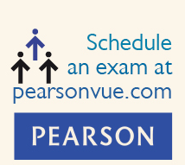

BECOME CERTIFIED
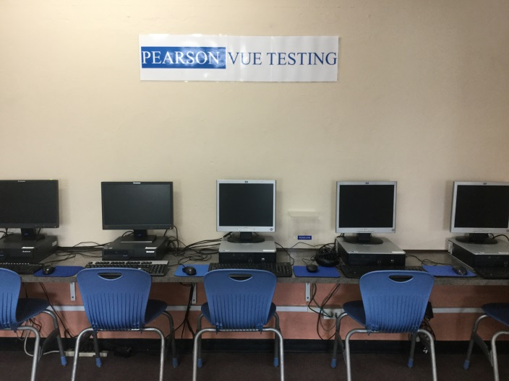
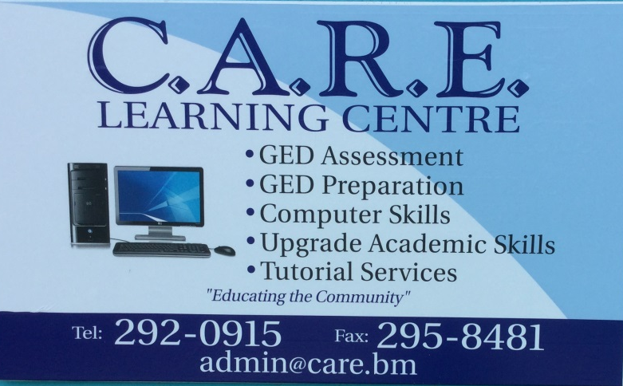

C.A.R.E. LEARNING CENTRE

REGISTRATION FORM
COURSES:
- G.E.D. PREPARATION
- MY GED READY
- EMPLOYABILITY SKILLS
- COMPUTER SKILLS
- PRODUCTIVITY COURSES
- UPGRADE PROGRAMMES
- AFRICAN CENTRED EDUCATION
LAST NAME: FIRST: M.I.
MAILING ADDRESS:

TEL: (H) __________ (W) _________ (C) E-MAIL:
LAST SCHOOL ATTENED: YEAR: ______
STUDENT SIGNATURE: D.O.B.
PROOF OF IDENTIFICATION: Passport/Driver’s Licence #
Monday Tuesday Wednesday Thursday Friday
DATE OF ENROLLMENT: CLASS TIME:
COURSE: FEE:



Lunch and Learn
Refresh, Renew or Revise
your Microsoft Word Skills
with C.A.R.E. Learning Centre

Bring your lunch and learn to refresh, renew and revise your Microsoft Word Skills on Wednesday, (when applicable) from 12:30 p.m. – 1:30 p.m. at C.A.R.E. LEARNING CENTRE located at the former Woodlands School, behind Arnold’s Market, St. John’s Road, Pembroke.


The course will be focusing on how to
upgrade your Microsoft word skills.
Cost: $40.00 payable upon registration
Please call 292-0915 or email admin@care.bm for more information.
We look forward to hearing for you. (Limited Space}




